ONE-PAGE ABSTRACT TEMPLATE AND GUIDELINES –TITLE CENTERED AND ALL CAPS

First name Family name of Primary Author, Affiliation
Email address of Primary Author
First name Family name of next author, Affiliation
First name Family name of next author, Affiliation
First name Family name of next author, Affiliation

Key Words: List up to five key words.

These guidelines have been prepared in the format that should be used for the abstract submission. Authors should replace the text of this template in order to prepare their abstracts. Fonts, sizes and spacing should be used as they are used in this document. Page size is US 8.5 inch x 11 inch, top and bottom margin 0.8 inches, left and right margin 0.8 inches. Body text should be written in Arial, 10 pt, single spacing. The Abstract, in English, should introduce the proposed paper’s subject, summarize its contents, explain any unique aspects, and clearly indicate the specific relevance to the themes of the Conference. Do not sub-divide the text into separate sections. References may be included at the bottom.

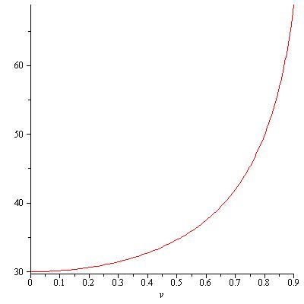
Figure 1 – Arial 10 pt Italics
The abstract may contain images, graphs or tables to help draw attention to the subject matter. The abstract must not exceed one page.

Please do not insert page numbers or headers and footers. These will be added later by the publisher. Abstracts should be submitted on-line using the web based abstract submission system operated by the conference. Please note that hard copies, e-mails or fax submissions will not be accepted.

Please proofread your abstract carefully prior to submission.

The abstract shall be submitted as Word File (.doc or .docx).

