Preliminary Program

(April 15, 2024) – DRAFT SUBJECT TO CHANGE

Biochemical and Molecular Engineering XXIII: Accelerating Biotech Solutions to aid a Changing World

July 21 – 25, 2024

Royal Marine Hotel
Dublin, Ireland

Conference Co-Chairs

Michelle O’Malley
University of California at Santa Barbara, USA

Brian Pfleger
University of Wisconsin, USA

Varnika Roy
GSK, USA

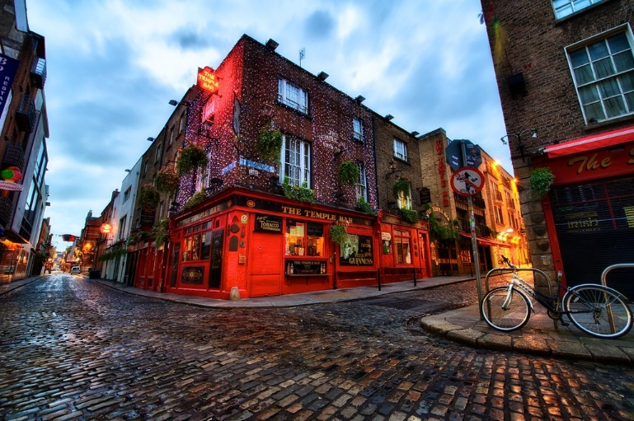

Engineering Conferences International
369 Lexington Avenue, 3rd Floor #389, New York, NY 10017, USA
www.engconfintl.org – info@engconfintl.org
Sunday, July 21, 2024

12:30 – 14:30 Conference Check-in

14:30 – 14:45 Opening Remarks (Conference Chairs and ECI Liaison)

14:45 – 16:45 Session 1: Biomanufacturing and building the workforce

Optogenetic control of protein production in Pichia pastoris replaces methanol induction with light
Jose Avalos, Princeton University, USA

Optimized manufacturing of Adeno-associated Virus for gene therapy
Nicholas Donohue, APC Ltd, Ireland

Transferring lab innovation into large scale application by thorough understanding of strains and processes
Ralf Takors, University of Stuttgart, Germany

Harnessing genome engineering and automation to engineer next-gen microbial production strains for biologics
Markus Mund, Sanofi-Aventis Deutschland GmbH, Germany

Deconstructing synthetic biology: a conceptual approach for training synthetic biologists
Ashty Karim, Northwestern University, USA

16:45 – 17:15 Coffee Break in Poster Area

17:15 – 18:15 Keynote
TBA
Henk Noorman, DSM

18:15 – 19:00 Rapid-fire Poster Talks 1

19:00 – 20:30 Dinner

20:30 – 21:00 Poster Session 1 and Social Hour

Monday, July 22, 2024

07:00 – 08:30 Breakfast

08:30 – 09:30 Keynote
TBA
Kelvin Lee, NIIMBL/University of Delaware, USA

09:30 – 12:30 Session 2: In vitro models & Cell Therapies

NRSF plays a central role in controlling µ-opioid receptor
Christina Chan, Michigan State University, USA

Predicting outcomes of cardiac progenitor cell differentiation to cardiomyocytes based on integrated transcriptomics and epigenomics
Sean Palacek, University of Wisconsin – Madison, USA

10:00 – 10:30 Coffee Break in Poster Area

Bioengineering of cancer stem cells for improved disease modelling
John Kim, University of Alabama, USA

Design of feeder-free processes for natural killer cell expansion
Samira Azarin, University of Minnesota, USA

How Biotechnology Innovation Drives Benefits to Patients and the Planet: Case Studies from Medicine Design & Manufacturing
Philip Dellorco, GSK, USA
12:30 – 14:00 Lunch
14:00 – 16:00 Session 3: Automation in Biotech & Democratizing Biotechnology

A Journey Towards the Development of a Cloud Biofoundry
Huimin Zhao, University of Illinois at Urbana-Champaign, USA

Overcoming the Risks in Biochemical Product Development and Manufacturing Through Rapid, Genome Scale Metabolic Engineering
Richard Fox, Inscripta, Inc., USA

Harnessing genome engineering and automation to engineer next-gen microbial production strains for biologics
Markus Mund, Sanofi-Aventis Deutschland GmbH, Germany

Accessible DNA construction from oligonucleotide pools using Golden Gate Assembly and Data-optimized Design
Sean Lund, New England Biolabs, USA

Growing global bioeconomies through perfusion fermentation
Kerry Love, Sunflower Therapeutics PBC, USA

16:00 – 16:30 Coffee Break in Poster Area

Monday, July 22, 2024 (continued)

16:30 – 18:00 Session 4: Synthetic & Systems Biology I

TBA
Zengyi Shao, Iowa State University

Rational design of effective CRISPR-Cas antifungals
Cong Trinh, University of Tennessee, Knoxville, USA

TBA
Katie Galloway, Massachusetts Institute of Technology, USA

TBA
Laura Segatori, Rice University, USA

18:00 – 19:00 Rapid-fire Poster Talks 2

19:00 – 20:30 Dinner

20:30 – 21:00 Poster Session 2 and Social Hour / Special After Dinner Session

Tuesday, July 23, 2024

07:00 – 08:30 Breakfast

08:30 – 09:15 Keynote
Evolution of the Irish Biotechnology Sector
Barry Heavey, Accenture, Ireland

09:15 – 13:00 Session 5: Protein & Metabolic Engineering

Hyperstable synthetic miniproteins as developable ligand scaffolds
Benjamin Hackel, University of Minnesota, USA

MAGMA-seq enables wide mutational scanning of human antibody libraries
Tim Whitehead, University of Colorado, Boulder, USA

Reprogramming plant hormone receptors as biosensors and chemically-inducible genetic circuits
Ian Wheeldon, University of California, Riverside, USA

Engineering enzymes by force: Modulating the catalytic activity of an alcohol dehydrogenase via mechanical forces applied by DNA springs
Scott Banta, Columbia University, USA

10:30 – 11:00 Coffee Break in Poster Area

The role of cofactor recycling in bacterial organelles for sustainable production of biochemicals
Danielle Tullman-Ercek, Northwestern University, USA

Engineering the Redox Chemistry of Life
Han Li, University of California, Irvine, USA

TBA
Matt DeLisa, Cornell University, USA

TBA
Anne Robinson, Carnegie Mellon University, USA

Production of supply-limited natural product therapeutics using engineered yeast
Jay Keasling, University of California at Berkeley, USA

13:00 – 14:15 Lunch

14:30 Excursion to Guinness Storehouse (Bus transportation provided)

Dinner on your own

Wednesday, July 24, 2024

07:00 – 08:30 Breakfast

08:30 – 09:30 Keynote
TBA
Corrine Scown, Lawrence Berkeley National Laboratory, USA

09:30 – 12:00 Session 6: Synthetic & Systems Biology II

Deconstructing and reconstructing polyethylene deconstruction pathways of mealworm gut microbiomes
Mark Blenner, University of Delaware, USA

Trash to Treasure: Converting Nitrogen Pollutants into Industrial Chemicals
Keith Tyo, Northwestern University, USA

10:00 – 10:30 Coffee Break in Poster Area

Unraveling the impact of climate change on Arctic diatom-cyanobacteria symbiosis and the global carbon cycle
Ranjan Srivastava, University of Connecticut, USA

CRISPR interference libraries for genome scale functional genomics
Carrie Eckert, Oak Ridge National Laboratory, USA

Strangers in a Strange Land: Challenges in the study of cellular interactions
Vassily, Hatzimanikatis, EPFL, Switzerland

12:00 – 14:00 Lunch and Poster Session II

14:00 – 17:30 Session 7: Synthetic & Systems Biology III

Optogenetic intensification of insulin secretion in pancreatic beta-cells for diabetes
Emmanuel Tzanakakis, Tufts University, USA

Highly multiplexed design of an allosteric transcription factor to sense novel ligands
Vatsan Raman, University of Wisconsin-Madison, USA

Harnessing a systems biology approach to unlock molecular processes behind cellular productivity between different Chinese Hamster Ovary cell hosts
Annie Harwood-Stamper, AstraZeneca, UK

15:30 – 16:00 Coffee Break in Poster Area

Engineering synthetic anaerobic consortia by division of labour for sustainable biomanufacturing
Christopher Lawson, University of Toronto, Canada

Wednesday, July 24, 2024 (continued)

Engineering and Design of Multifunctional Metalloproteinase Inhibitors
Maryam Raeeszadeh-Sarmazdeh, University of Nevada, Reno, USA

SynBio in the Soil: Tools, Models, and Applications
Natalie Farny, Worcester Polytechnic Institute, USA

Targeted DNA insertion in plants by CRISPR-associated transposons
Gozde Demirer, Caltech, USA

TBA
Aindrila Mukhapadhay, Lawrence Berkeley National Laboratory, USA

17:30 – 18:30 Amgen Award Lecture
TBA
William Bentley, University of Maryland, USA

18:45 – 20:15 Reception

20:15 – 22:30 Gala Dinner

Thursday, July 25, 2024

07:00 – 08:30 Breakfast Buffet

08:30 – 09:30 BEJ Lecture
TBA
Kevin Solomon, University of Delaware, USA

09:30 – 13:00 Session 8: Protein & Metabolic Engineering II

Development of recombinant platforms for the upcycling of waste to protein-based biopolymers
Mattheo Koffas, Rensselaer Polytechnic Institute, USA

Unveiling Paclitaxel Biosynthesis: Integrating Engineered Microbial Consortia and Functional Genomics to discover a Crucial Taxane Hydroxylase
Leonardo Rios Solis, University College London, UK

Harnessing acetogenic bacteria for sustainable chemical production: a systems and synthetic biology approach
Benjamin Woolston, Northeastern University, USA

10:00 – 10:30 Coffee Break

TBA
Kristala Prather, Massachusetts Institute of Technology, USA

TBA
Mike Betenbaugh, Johns Hopkins University, USA

Into Darkness: Understanding non-coding regions of the CHO genome
Nicole Borth, BOKU University, Austria

Closing Remarks

13:00 Lunch and Departures

