Preliminary Program
(May 10, 2023)

SIXTH INTERNATIONAL WORKSHOP ON ENVIRONMENTALLY-ASSISTED CRACKING
July 16 - 21, 2023

Sheraton Reston Hotel
Washington, DC area, USA

Conference Chairs
A.K. Vasudevan
Office of Naval Research (retired)

R. Latanision
Exponent, Inc

H. Holroyd
Luxfer (retired)

F. Friedersdorf
Luna Labs USA, LLC

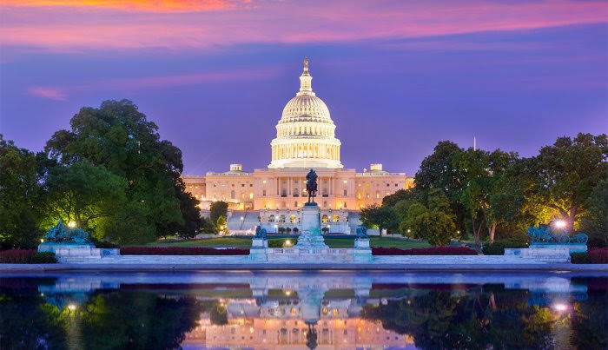

Engineering Conferences International
369 Lexington Avenue, 3rd Floor #389 - New York, NY 10017, USA
www.engconfintl.org – info@engconfintl.org
Sunday, July 16, 2023

16:00 – 18:00 Conference check-in

18:00 – 18:30 Opening Reception

18:30 – 20:00 Dinner

Monday, July 17, 2023

07:30 – 08:30 Breakfast
Session 1
Chair: Dave Rusk, Naval Air Warfare Center Aircraft Division, USA

08:30 – 09:20 Keynote
Environment-induced crack initiation in metals - experimental studies
Henry Holroyd, Consultant, USA

09:20 – 09:50 Relating material microstructural development and modeling damage
parameters for crack initiation: comparison between air and hydrogen
May Martin, National Institute of Standards and Technology, USA

09:50 – 10:20 Effect of laser surface treatment on the corrosion and fatigue performance
of aa5456-h116 alloys
Rajaguru Jeyamohan, University of Virginia, USA

10:20 – 11:00 Coffee Break

11:00 – 11:30 Characterizing environmentally assisted crack initiation and short crack
growth
Tim L. Burnett, The University of Manchester, United Kingdom

11:30 – 12:00 Evaluation of chloride stress corrosion susceptibility of stainless steels
Earl Johns, Naval Nuclear Laboratory; Fluor Marine Propulsion, USA

12:00 – 13:30 Lunch

Session 2
Chair: Siddiq Qidwai, National Science Foundation, USA

13:30 – 14:20 Keynote
Modeling electrochemically assisted hydrogen adsorption on alloy
surfaces
Chris Taylor, DNV GL and Ohio State University, USA

14:20 – 14:50 Modeling stress corrosion cracking in stainless steel using phase field
method
Mehdi Naderi, Technical Data Analysis, Inc ,USA

14:50 – 15:20 Electrochemical-mechanical phase field model for electroplating process
Jung Ho Yang, Technical Data Analysis, Inc., USA

15:20 – 16:00 Coffee Break

16:00 – 16:30 Dynamic hydrogen dilation model for hydrogen embrittlement
Michael McGuire, Carnegie Mellon University ret, USA

16:30 – 17:00 Combined damage-fracture model for corrosion fatigue crack growth in 3D
parts
Alexander Staroselsky, Raytheon Technologies Research Center, USA

Dinner on your own

Tuesday, July 18, 2023

07:30 – 08:30 Breakfast
Session 3
Chair: TBD

08:30 – 09:00 Advances in peridynamic modeling of environmentally- assisted cracking
Florin Bobaru, University of Nebraska-Lincoln, USA

09:00 – 09:30 A computational framework for prediction of atmospheric
Mehdi Amiri, George Mason University, USA

09:30 – 10:00 Correlating nature of precipitates with environmental degradation in
aluminum alloys
Ramasis Goswami, US Naval Research Laboratory, USA

10:00 – 10:30 Coffee Break

10:30 – 11:00 Microstructural crack path prediction using graph theory
Veera Sundararaghavan, University of Michigan, USA

11:00 – 11:30 The influence of additive manufacturing (3D printing) on susceptibility to
environmentally induced fracture
Rick Ricker, University of Maryland, USA

11:30 – 12:00 New aluminum alloy design
Asuri Vasudevan, Office of Naval Research (Retired), USA

12:00 – 13:00 Lunch

13:30 – 16:30 Excursion - National Air and Space Museum - The Steven F. Udvar-Hazy
Center VA

Wednesday, July 19, 2023

07:30 – 08:30 Breakfast
Session 4
Chairs: Victor Rodriquez-Santiago, NAWCAD, USA

08:30 – 09:20 Keynote
Quantification of environmentally-assisted cracking mechanisms with high-
resolution characterisation
Sergio Lozano-Perez, University of Oxford, United Kingdom

09:20 – 09:50 Atomic mechanism of near threshold fatigue crack growth in vacuum as a
basis for understanding environmental effects
Derek Warner, Cornell University, USA

09:50 – 10:20 Macro to micro approach toward the evaluation of the fracture energy
Dov Sherman, Tel-Aviv University; School of Mechanical Engineering,
Israel

10:20 – 11:00 Coffee Break

11:00 – 11:30 Electrochemical activities at the crack tip: A localized approach
Mehdi Amiri, George Mason University, USA

11:30 – 12:00 Digital image correlation to study stress corrosion cracking of aluminum alloys
Marina Cabrini, University of Bergamo, Italy

12:00 – 13:30 Lunch

Session 5
Chairs: Eric Lindgren, AF, USA

13:30 – 14:20 Keynote
Dynamic fracture in dealloying induced stress-corrosion cracking
Karl Sieradzki, Arizona State University, USA

14:20 – 14:50 Surface stress in metals induced by organic monolayer films
Srinivasan Chandrasekar, Purdue University, USA

14:50 – 15:20 Modeling hydrogen diffusion in precipitation hardened nickel alloy
Attilio Arcari, Naval Research Laboratory, USA

15:20 – 16:00 Coffee Break

16:00 – 16:30 Electrochemical assessment of time-dependent diffusible hydrogen release
in X65 pipeline steel samples charged with hydrogen
Alessandro Carrozza, University of Bergamo, Italy

16:30 – 17:00 Development of a lifetime prediction model for evaluating the sensitivities
of aiscc susceptibility in stainless-steel nuclear waste storage canisters
Sarah Blust, University of Virginia, USA

17:00 – 18:00 Poster Session / Reception

Dinner on your own

Thursday, July 20, 2023

07:30 – 08:30 Breakfast
Session 6
Chairs: Earl Johns, Naval Nuclear Laboratory, USA

08:30 – 09:20 Keynote
Is laboratory testing of scc susceptibility fit for purpose?
Alan Turnbull, NPL, United Kingdom

09:20 – 09:50 Environment-assisted fracture, my friend: The cutting of gummy metals
Ronald M. Latanision, Exponent Inc.; Massachusetts Institute of Technology,
USA

09:50 – 10:20 Unusual behavior of long cracks at low dk: Marci effect
Daniel Kujawski, Western Michigan University, USA

10:20 – 11:00 Coffee Break

11:00 – 11:30 The effect of atmospheric environment parameters on corrosion fatigue
damage
Sarah E. Galyon Dorman, SAFE Inc, USA

11:30 – 12:00 Fatigue threshold K_{max,th} affected by static threshold K_{1scc}
Asuri Vasudevan, TDA, Inc, USA

12:00 – 13:30 Lunch

Session 7
Chairs: TBD

13:30 – 14:00 Environmental effects on the fatigue crack growth of low carbon nitrogen
alloyed stainless steel
M. Nani Babu, Metallurgy and Materials Group, Indira Gandhi Centre for
Atomic Research, India

14:00 – 14:30 Assessing the loading rate dependence of hydrogen environment-assisted
cracking behavior in a wide-range of engineering alloys
Michael Roach, University of Virginia, USA

14:30 – 14:50 Coffee Break

14:50 – 15:20 Fracture toughnes K_{1c} affecting static threshold K_{1scc}
Asuri Vasudevan, TDA, Inc., USA

15:20 – 15:50 Atmospheric laboratory and outdoor testing of aluminum alloy
environment assisted cracking
Fritz Friedersdorf, Luna Labs USA, LLC, USA

19:00 – 21:00 Conference Banquet
Friday, July 21, 2023

07:30 – 08:30 Breakfast

09:00 – 11:00 Panel Discussion: The path forward: The convergence of modeling and experiment in EAC
Moderator: Ron Latanision, Exponent Inc, USA.

Panelists: Keynote speakers and government program managers
11:00 – 11:20 Workshop Closing

11:30 – 12:30 Lunch

